Van Lang University

Software Measurement and Analysis course

**RISK MANAGEMENT PLAN**

**Version number:** 1.0

**Author:** K14T01 – Team 01

**Team member:**

Duong Nguyen

Mung Nguyen

Manh Nguyen

Binh Huynh

Hien Nguyen

**Table of Content**

1. INTRODUCTION 1
2. RISK MANAGEMENT PROCESS 1
3. QUANTITATIVE RISK ANALYSIS 2
4. QUALITATIVE RISK ANALYSIS 3
5. THE TOP 10 RISK 4
6. RISK REPORT TEMPLATE 4
7. **INTRODUCTION**

* This document is to specify the process and method to manage and control risks that maybe affect the software project.
* To identify potential problems and priorities before they occur so that risk-handling activities maybe planned to mitigate adverse impacts on achieving objectives.
* This plan identifies the key strategic decisions to solve risks that are likely to impact adversely on the Viking Project.

1. **RISK MANAGEMENT PROCESS**

Risk management is a critical aspect of the success of the project. It should plan and budget to ensure that known and potential risks identify, prioritize and mitigate. Viking project will execute following the risk management process as mentioned below.

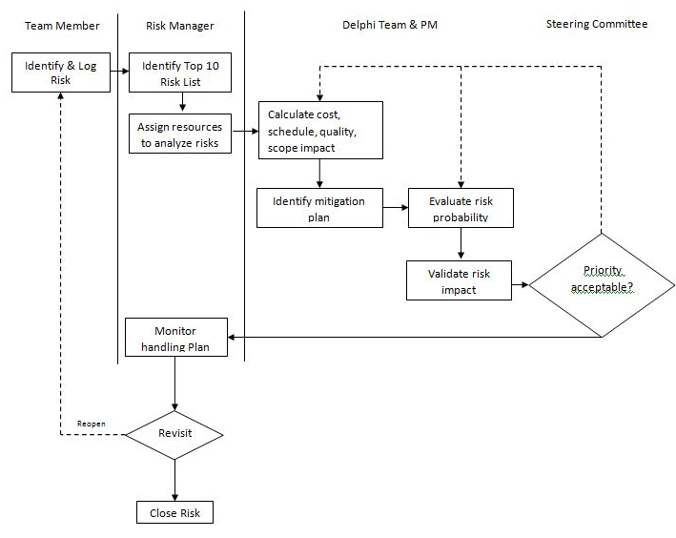

**Figure: Risk Management Process**

1. **Identify risks**

* Risk Manager will lead the risk identification process.
* The risks will identify by questionnaire, workshop, brainstorming method or historical data by all team member through the issue log to notify risk manager by Risk Identification Template.
* Risk Manager will be to generate a Top Risk list and assign resources to analyze risk.

1. **Analyze risks**

* Delphi Team will be evaluated, qualified and quantified using a Delphi ranking approach to provide their assessment of the probability and impact based on Quantitative and Qualitative analysis and historical data.
* Refer to the Table_ , Table_ and Table to determining the level of probability and impact.

1. **Evaluate risks**

* This stage of the risk assessment process determines whether the risks are acceptable or unacceptable. This decision made by Steering Committee meeting.
* A risk has a plan for managing and resolution alternatives the risk.
* A risk that is determined as acceptable that should be monitored and periodically reviewed to ensure it remains acceptable.
* A risk deemed unacceptable should be re - analyze.

1. **Monitor and report**

* Risk Managers are required to report on the progress of risk at regular intervals and has responsibility to identify new risks.
* The person who has the responsibility for a risk is expected to provide feedback on the progress of the risk.

Following diagram provides detailed risk management process for the Viking project management:

1. **QUANTITATIVE RISK ANALYSIS**

Quantitative Risk Analysis will be performed during the Calculate Risk Cost, Schedule & Quality Impacts and Evaluate Risk Probability phase of the Risk Management Process by Delphi Team and Project Manager. This group will calculate the impacts to the cost, schedule, scope and quality of the Viking project based on data in *Table_* .

|  |  |  |  |  |  |
| --- | --- | --- | --- | --- | --- |
| **Project**  **Objective** | **Very Low** **(0,05)** | **Low (0,1)** | **Moderate (0,2)** | **High (0,4)** | **Very High (0,8)** |
| **Cost** | Insignificant Cost | Increase  <4% Cost | Increase  5-10% Cost | Increase  10-20% Cost | Increase  >20% Cost |
| **Schedule** | Insignificant Schedule Slippage | Schedule  Slippage <5% | Overall Project  Slippage  5-10% | Overall Project  Slippage  10-20% | Overall Project  Schedule Slips  >20% |
| **Scope** | Scope Decrease Barely Noticeable | Minor Areas of  Scope are  Affected | Major Areas of  Scope are  Affected | Scope Reduction  Unacceptable to  the Stakeholder | Project End Item  is Effectively  Useless |
| **Quality** | Quality Degradation Barely Noticeable | Only Very Demanding Applications are  Affected | Quality Reduction  Requires  Stakeholder  Approval | Quality Reduction  Unacceptable to  the Stakeholder | Project End Item  is Effectively  Unusable |

*Table_ 1.*

The following Table_ shows Risk Probability that will be used by Delphi Team and Project Manager to estimate risk probability.

|  |  |  |
| --- | --- | --- |
| **Descriptor** | **Probability Value** | **Even Definition** |
| Certain  (80% - 100%) | **0.9** | * The risk is a wide spread issue affecting Organization. * The risk will occur within 1-3 months. * A similar outcome has been occurring over the past year |
| Imminent  (60% - 80%) | **0.7** | * The risk is a large issue affecting Organization. * The risk will occur within 3-4 months. |
| Likely  (40% - 60%) | **0.5** | * The risk is a medium issue affecting Organization. * The risk will occur within 4-7 months. |
| Possible  (20% - 40%) | **0.3** | * The risk is a low issue affecting Organization. * The risk will occur within 7-12 months. |
| Unlikely  (0% - 20%) | **0.1** | * The risk is a very low issue affecting Organization. * The risk will occur within more than 12 months. |

Table_2.

1. **QUALITATIVE RISK ANALYSIS**

The following table shows how the Risk Score is calculated and the priority determined. Using the Risk Score matrix and both the Probability P and Impact I they are able to calculate a Risk Score. The Risk Scores have been grouped into High – Red, Medium – Yellow, and Low – Green. By determining the Risk Score you can determine the relative priority of the Change Request should the mitigation plan early.

|  |  |  |  |  |  |
| --- | --- | --- | --- | --- | --- |
| P | Risk Score = P x I ( priority | Risk Score ) | | | | |
| 0.9 | 17 | 0.045 | 12 | 0.09 | 8 | 0.18 | 4 | 0.36 | 1 | 0.72 |
| 0.7 | 19 | 0.035 | 14 | 0.07 | 9 | 0.14 | 5 | 0.28 | 2 | 0.56 |
| 0.5 | 21 | 0.025 | 16 | 0.05 | 11 | 0.10 | 7 | 0.20 | 3 | 0.40 |
| 0.3 | 23 | 0.015 | 20 | 0.03 | 15 | 0.06 | 10 | 0.12 | 6 | 0.24 |
| 0.1 | 25 | 0.005 | 24 | 0.01 | 22 | 0.02 | 18 | 0.04 | 13 | 0.08 |
| I | 0.05 | 0.1 | 0.2 | 0.4 | 0.8 |

Table_3.

|  |  |  |
| --- | --- | --- |
|  | **Risk Level** | |
|  | High | Major disruption of the plan  Senior management attention needed  Immediate action required |
|  |
|  | Medium | Some disruption in the plan  Senior management attention needed  Managed by specific monitoring or response procedures |
|  |
|  | Low | Little or no disruption to plan  Managed by routine procedures |

1. **THE TOP 10 RISK**

Refer to the *Viking Top 10 Risk List.xlsx*

1. **RISK REPORT TEMPLATE**

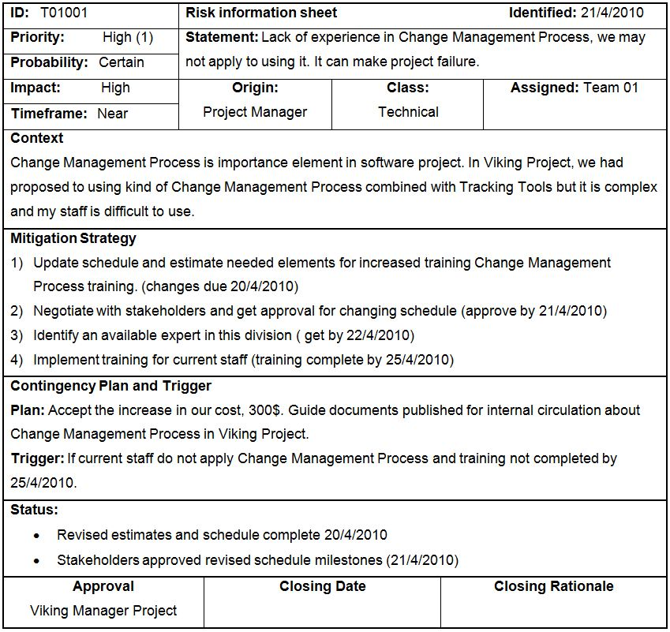

Figure_2.